APPENDIX C
[Steps in the Systematic review process]

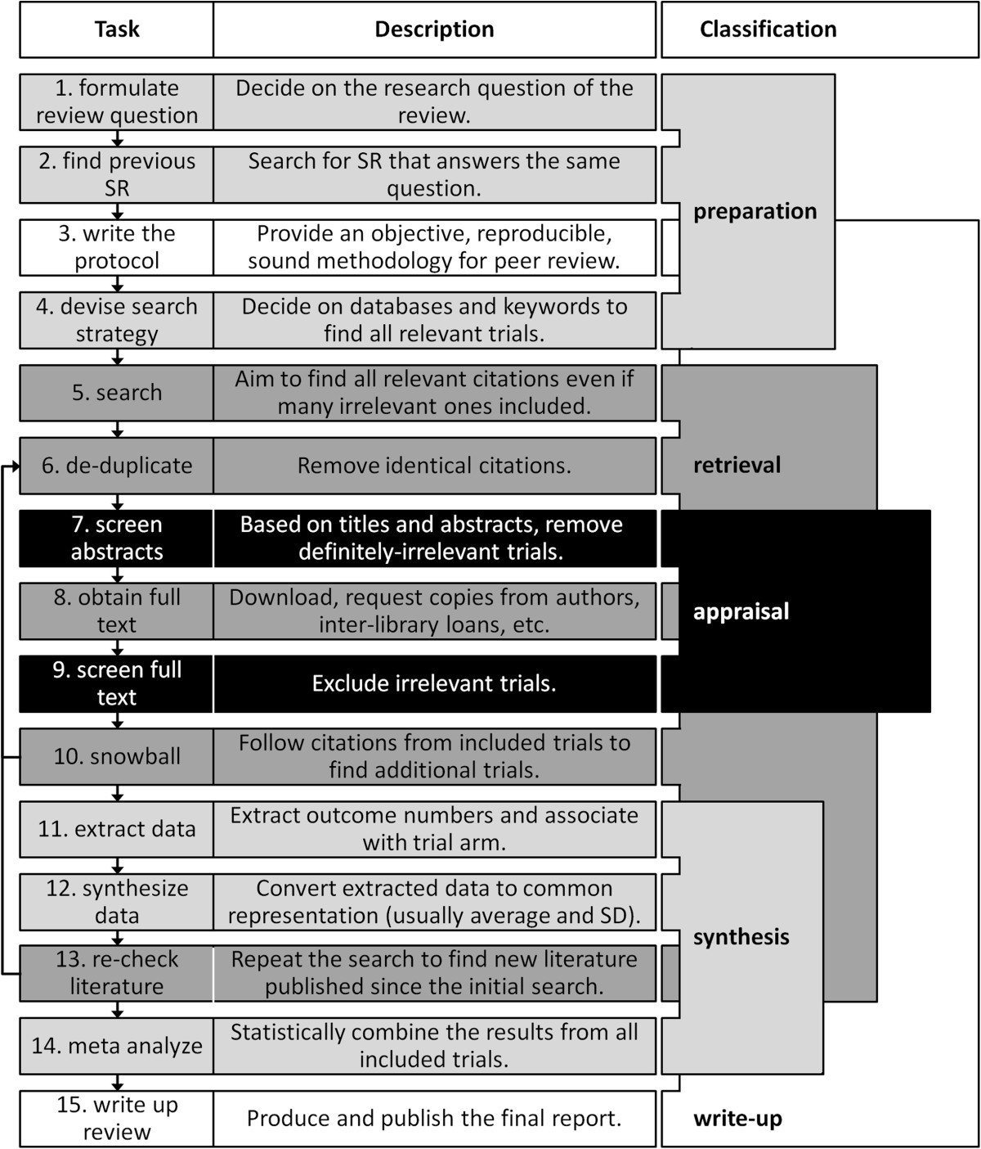

Source: Tsafnat, G., Glasziou, P., Choong, M.K. et al. Systematic review automation technologies. Syst Rev 3, 74 (2014). https://doi.org/10.1186/2046-4053-3-74

