Appendix A

Supplementary Figure 1: Questionnaire
How satisfied are you with health information project ? | Very satisfied | Satisfied | Neutral | Dissatisfied | Very dissatisfied
 | Very much | Much | Enough | Little | Very little
Materials provided were able to respond to your need and requests?

Do you consider text and materials provided of good quality?

Do you consider health information prescription useful?
Which aspects related to your disease and health status do you consider more influenced by information?  Multiple answers allowed | Awareness and knowledge of disease | Patient-physician communication | Communication with family | Adherence to treatment | No benefit
Other (specify)
…………………………
……………

What are the main emotions felt after receiving information?  Multiple answers allowed | Comfort | Discouragement | Safety | Anxiety, worry | Confusion
 | Other | ………………………………….. | ……………… | …………………………. | ……………….  ……………….
Write your personal comments in the free box (ideas, suggestions for improvement, critical points, psycho-emotional impact of the project)
...............................................................................................................................................................
...............................................................................................................................................................
...............................................................................................................................................................
...............................................................................................................................................................

Supplementary Figure 2. Topics of major interest requested by patients.
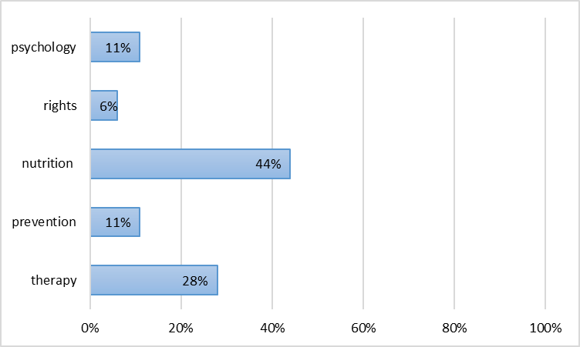

Supplementary Figure 3. The aspects of self-management of disease most influenced by health information.
Abbreviations “knowledge” :knowledge and awareness about disease; “comm physician”:communication with physician; “comm family”:communication with family members; “adherence”: adherence to treatment
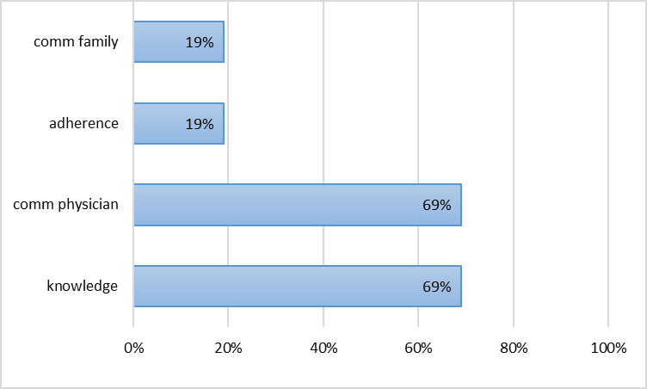

Supplementary Figure 4. Psychological impact of prescription information. The main emotions felt are reported in this figure.
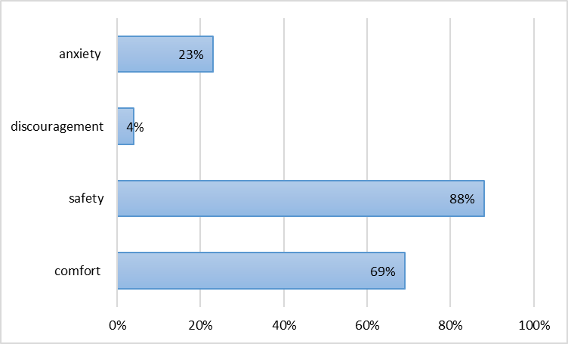

Supplementary Figure 5 Word cloud: visual representation of keywords used in patient comments. The most frequent keywords are represented in the figure in larger size than the less frequent ones.
