Appendix A
Survey Email
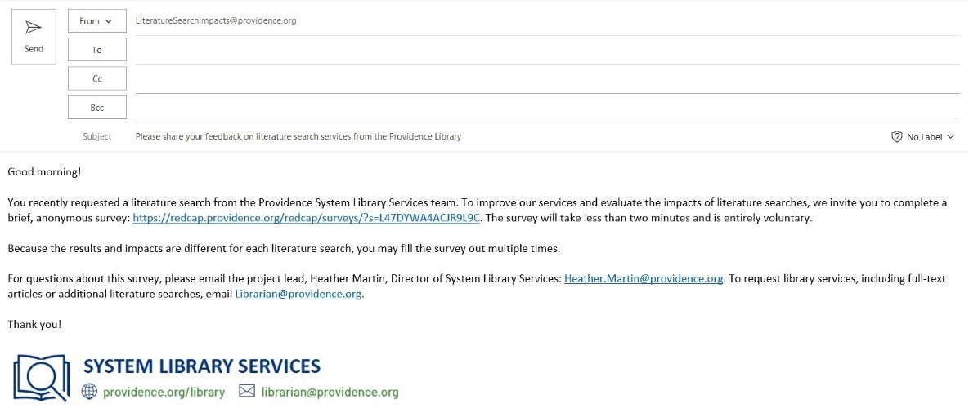RedCap Survey Questions
Where do you work? ​
- Alaska
- California
- Montana
- New Mexico
- Oregon
- Texas
- Washington
- Another state
- Outside the US
What is your primary role? Check all that apply.​
- Nursing staff
- Allied health
- Administration
- Student
- Researcher
- Medical staff
- Pharmacy
- Educator
- Resident/Fellow
- Other​
Did the results of this literature search have an impact on any of the following? Check all that apply.​
- Added to knowledge base
- Modification of current clinical practice
- Confirmation of current clinical practice
- Modification of current policy
- Confirmation of current policy
- Diagnosis
- Length of patient stay
- Choice of tests
- Choice of medications
- Advice given to patient
- Increased productivity
- Other​
Did receiving these search results save you time?​
- No
- Saved less than 1 hour
- Saved between 1 and 3 hours
- Saved between 4 and 6 hours
- Saved more than 7 hours​
How would you rate the quality of the search results?​
- Very high quality
- High quality
- Neither high nor low quality
- Low quality
- Very low quality​
Do you have any comments about this search or other library services?​

