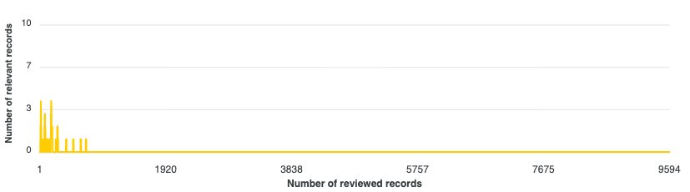
Figure 1 – Simulation progress graph for the AI Ethics narrow search strategy (run #1).

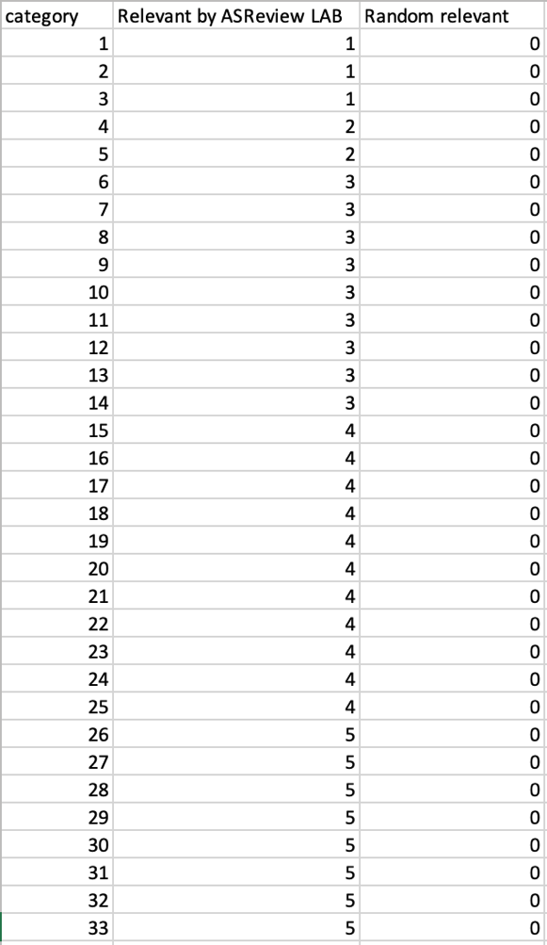
Figure 2 – Partial simulation result output for the AI Ethics narrow search strategy (run #1). The column “category” shows the number of articles reviewed by the active learning algorithm. “Relevant by ASReview LAB” represents the total number of included articles identified when using active learning re-prioritization, while “Random relevant” indicates the total number of included articles found without re-prioritization.

